* **Sales Representative Performance Data:**  
  The following table summarizes the performance metrics of some of our sales representatives. *Note: All of their average cost is approximately $500 plus commission.*

| **Sales Representative** | **Total Deals** | **Total Deal Value** | **Approved Deal Value** | **Active Months** | **Average monthly deals** | **Average Month Total Deals** | **Average Month Approved Deals** |
| --- | --- | --- | --- | --- | --- | --- | --- |
| Alina Victor | 142 | 244850.70 | 196192.20 | 18 | 7.89 | 13,602.82 | 10,899.57 |
| Damon | 55 | 106484.00 | 89046.00 | 14 | 3.93 | 7,606.00 | 6,360.43 |
| Rooney Rodriguez | 62 | 109526.26 | 101363.26 | 15 | 4.13 | 7,301.75 | 6,757.55 |
| Camilla Ali | 36 | 33891.50 | 10472.50 | 7 | 5.14 | 4,841.64 | 1,496.07 |
| John Reed | 8 | 9276.00 | 3001.00 | 8 | 8 | 9276.00 | 3001.00 |
| Ryan Rehman | 8 | 7290.00 | 5059.00 | 1.5 | 5.33 | 4860.00 | 3372.67 |
| Robin Miller | 7 | 8743.24 | 4,206.25 | 1 | 7 | 8743.25 | 4206.25 |
| Joshua Weller | 6 | 9130.00 | 6134 | 2 | 3 | 4565.00 | 3067.00 |
| Pamela Ross | 62 | 57537.75 | 35136.75 | 15 | 4.13 | 3,835.85 | 2,342.45 |

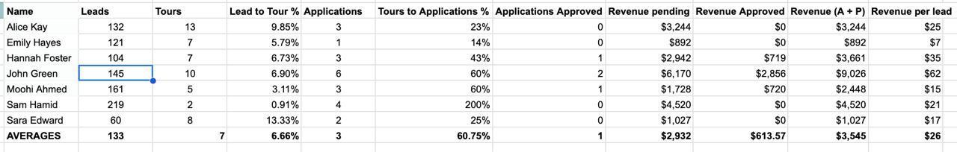

*May Performance Above*